9/1/2019

Ajit Ghising, Dawa Zangmu Sherpa, Dipendra Poudel, Dinesh Aryal

TEAM1

LIMINALVR Project1 ITECH3208

Iteration 1 Documentation

# Executive Summary

The project is based in organization which has developed procedures intended to improve quality of life using different kinds of virtual reality experiences. As we know that virtual reality is that experience which is completely different from the real world which is very interesting to all the teenage students as they can feel different experience behind the real world.

So according to the team discussion we came up with the idea that the project will be based on seeks to create an experience to ‘wake’ them up and get them motivated to ace the test! For this project we are going to use various development tools such as Blender ,Unity, GitHub and Audacity which will result in the succeeding of our Liminal VR project, which not only includes the Virtual reality video that is exciting but it also going to make viewer energetic.

A Work Breakdown Structure, Gannt chart and Milestone plan have been created to outline project tasks and the expected timelines. These diagrams also assign team responsibility. Key dates include:

* Requirement analysis due by 1st September 2019
* Design due by 1st September 2019
* Testing due by (Nest Semester)
* Audio due by (Next semester)
* Coding due by (Next semester)

Project risks have also been considered and listed. Each item has a mitigation action assigned. Some of the potential risks include:

* Conflict between team members
* Ill-defined scope (Leads to conflict, rework, and stakeholder dissatisfaction)
* Lack of change management process
* Inadequate design

A tasks list has been created to assign and track completion of team member individual tasks.

A regular meetings schedule has been established which will be used throughout the project to ensure clear and constant communication between the team, client and Manager. Team Members are using the various type of social media to discuss the project progress in a group where everyone is connected 24/7. Members are also using the collaboration tool [GitHub](https://github.com/login) to see progress of each team members. Examples of team communications have been included in an appendix.

The project plan is a detailed list of project tasks, resources and timelines and enables the team and supervisor to track progress against expected dates and effectively manage risks.

Contents

Executive Summary 1

Introduction 3

Context of the project 3

Group Details 3

1.1 Project Overview 3

2. Organization 4

2.1 Process Model 4

2.2 Organizational Structure 7

2.3 Organization Boundaries and Interfaces 7

2.3.1 GitHub Communication 7

2.3.2 Meeting times 12

2.4 Project Responsibilities 12

**APPENDIX: COMMUNICATION** 12

**MEETING AGENDA** 12

# Introduction

### Context of the project

The experience is to be designed for Oculus Go. We need to integrate the points of interactions with the use of controller’s trigger or touch surface as inputs. This project relies heavily on UX, so we are advised to conduct a UX testing at the end of each sprint using proper testing techniques. The learning from the UX testing, should be incorporated in next sprint of development.

# Group Details

|  |  |  |  |
| --- | --- | --- | --- |
| Team Member | Phone | Email | GitHub ID |
| Ajit Ghising | 0406247815 | azit.ghising@gmail.com | azit.ghising@gmail.com |
| Dawa Zangmu Sherpa | 0452658651 | dawazangmus@gmail.com | dawazangmus@gmail.com |
| Dinesh Aryal | 0405113321 | dinesharyal000@gmail.com | dinesharyal000@gmail.com |
| Dipendra Poudel | 0451874115 | connectdepen@gmail.com | connectdepen@gmail.com |

# 1.1 Project Overview

In today’s world, everything is about the technology and it is getting very popular day by day. Every single day technology comes up with some new idea to make human life easier and faster. VR is one of the most popular technology to experience something new in life and the other thing it is totally different form the real world.

Firstly, Virtual reality is an artificial environment that is created with software and presented to the user in such a way that the user suspends belief and accepts it as a real environment. Virtual reality helps students discover how the software can be used in other fields such as medicine, entertainment, and fashion among others. VR assists students with learning and knowledge retention. The technology software allows students to explore and move around their classrooms while learning. So, this seems to be very helpful technology for the students for their motivation and to stay focused in class and avoid distracted which makes students to keep their focus on what they are learning.

On the other hand, virtual reality helps to expand or increase your thinking or imagination. It can lead to experiencing new and exciting discoveries which have an influence on our day to day lives. Moreover, it is indeed beneficial in the educational system. It enables students to easily grasp what they try to understand when being taught by their educators; teachers, lecturers or professors. Virtual reality is applicable in the educational field since it simplifies the learning process for students by bringing their virtual environment to reality.

Therefore, in this scenario, our project will aim to focus on student to maintain their study progress better through VR experience where they are going to fell energetic to stay on test.

Reference Materials

<https://whatis.techtarget.com/definition/virtual-reality>

<https://www.eturbonews.com/174015/role-virtual-reality-education/>

Definitions and Acronyms

VR: Virtual Reality

UX: User experience

# 2. Organization

## 2.1 Process Model

We are the students of the federation university, currently studying in ATMC campus Sydney. We are assigned to develop VR experience for student where they are going to fell energetic to stay on test.

This project relies heavily on user experience, so we are advised to conduct a UX testing at the end of each sprint using proper testing techniques. The learning from the UX testing, should be incorporated in next sprint of development

We have chosen calm experience for the liminal VR project where calm state is identified as an emotional and cognitive demission i.e. Jurassic world. the calm experience that we choose to create for the liminal platform is aimed to be around 3 minutes or less in length where the environment is the Jurassic world and the user calming experienced are passive in nature.

We are going through a passive approach, users should be sitting or lying still because passive VR is well suited for deep relaxation purposes users need to do so. The key of this experience is constant progression and evolving content by maintain the engagement with users in experience. for this we are implementing “nature “which is one of the calm principals and technic.as it is the passive experience (Jurassic world) both real and digital interaction with this Jurassic nature can be extremely beneficial for refreshment, stress relief also reduce cognitive fatigue.

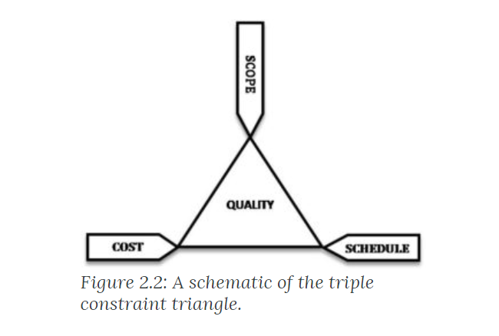

**WORK BREAKDOWN STRUCTURE**

|  |  |  |  |
| --- | --- | --- | --- |
| **PROJECT TITLE** | **Energizing Experience (Liminal VR)** | **COMPANY NAME** | Liminal VR |
| **PROJECT MANAGER** | Wallyat Hussain | **DATE** | 01-09-2019 |

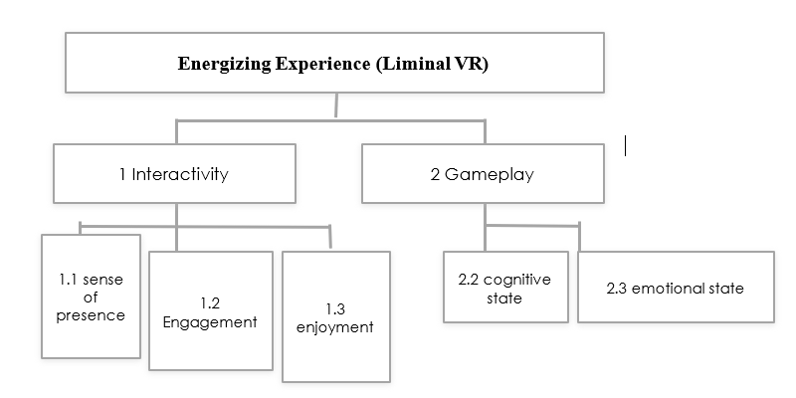

**Project plan timeline**

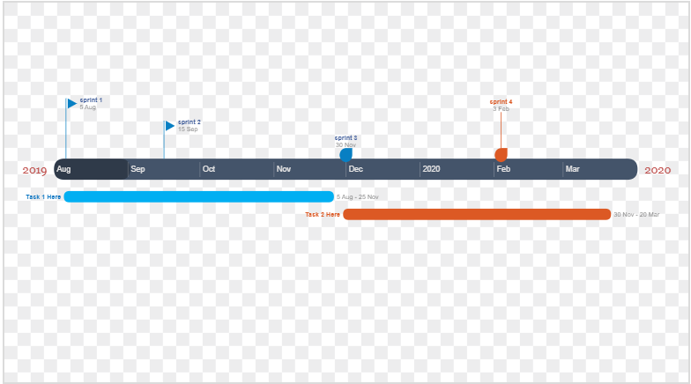

**Sprint review chart**

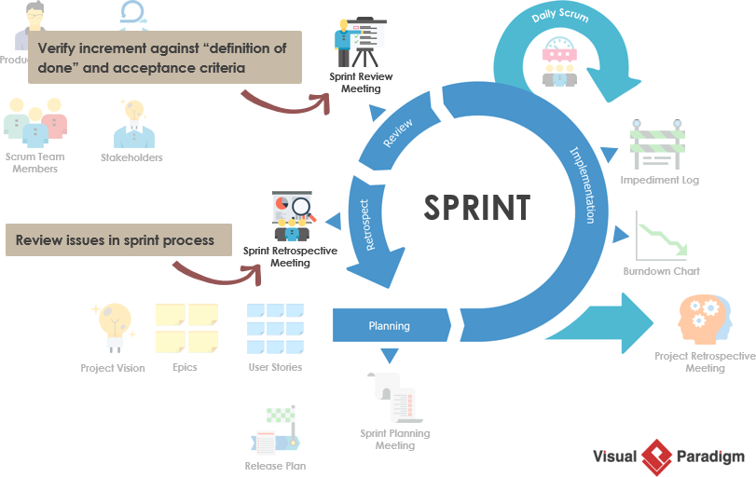

## 2.2 Organizational Structure

The above figure shows the team structure of the project team where Damian Moratti is the CEO and co-founder of Liminal. He is an entrepreneur with almost a decade of experience starting and running I.T. support and eMarketing businesses. The whole communication in this project is done with him about the functional and non-functional requirements of the Liminal.

Walayat Hussain is our project supervisor who supervise us what things need to be focused and submitted in respective time and provides all the resources and tools needed in this project.

Team1 is the name of the team where Ajit Ghising (Team leader) leads the team in a pace so that the project requirements are finished on time and Dawa Zagmu Sherpa, Dipendra Poudel and Dinesh Aryal are the member of this team who helps to finish this project.

## 2.3 Organization Boundaries and Interfaces

## 2.3.1 GitHub Communication

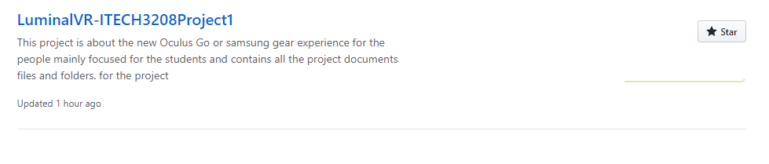

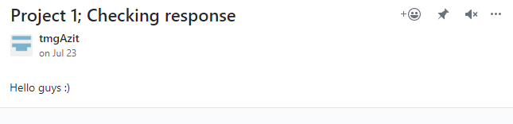

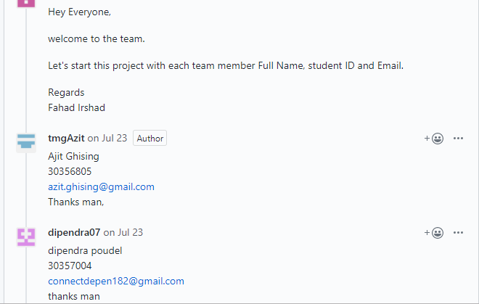

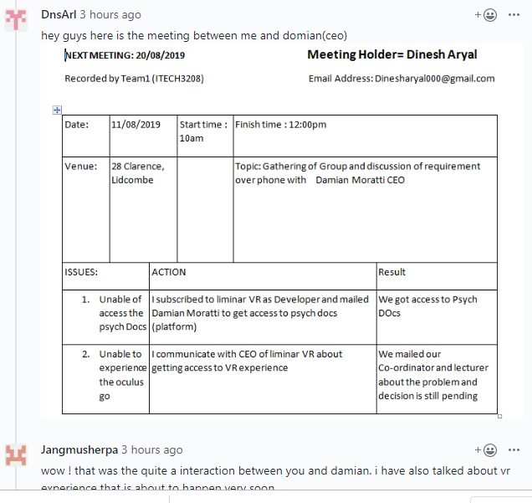

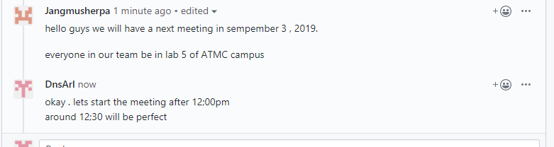

As our team have done a lot of communication and discussion through GitHub but the platform did not allow us to share the files so we use social media and e-mail (Facebook and Gmail) to share the files.

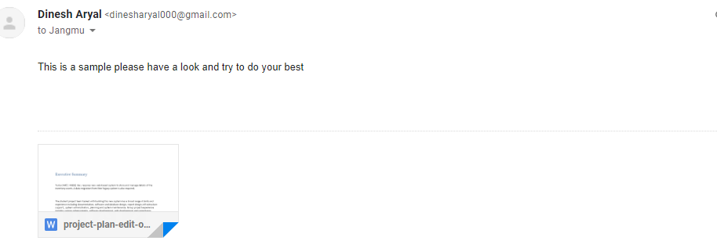

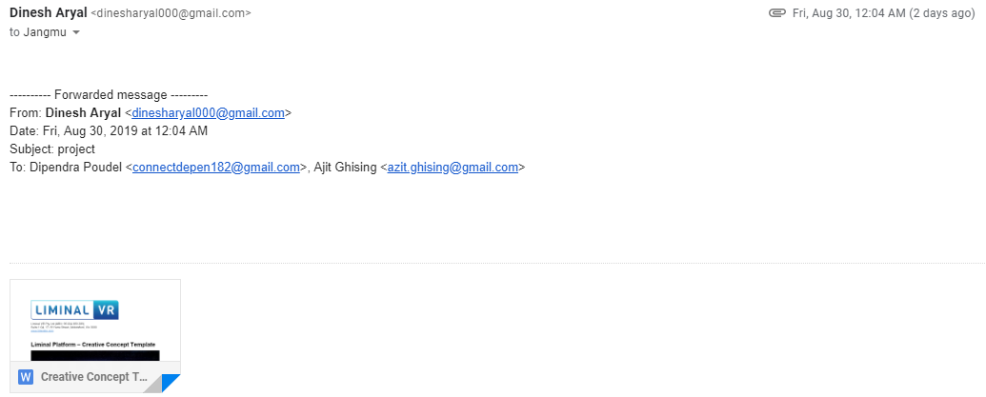

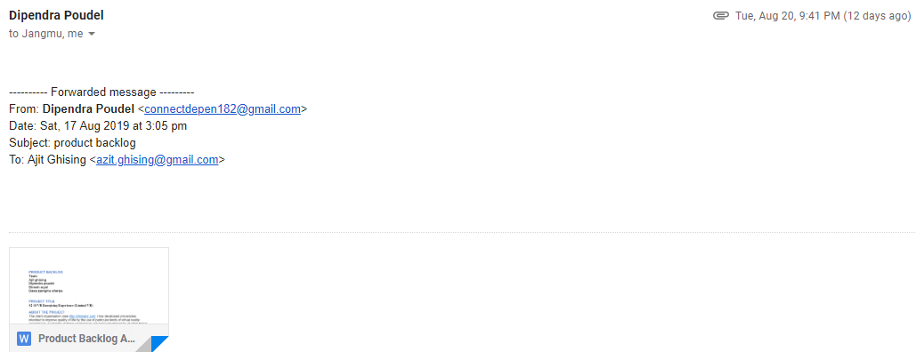

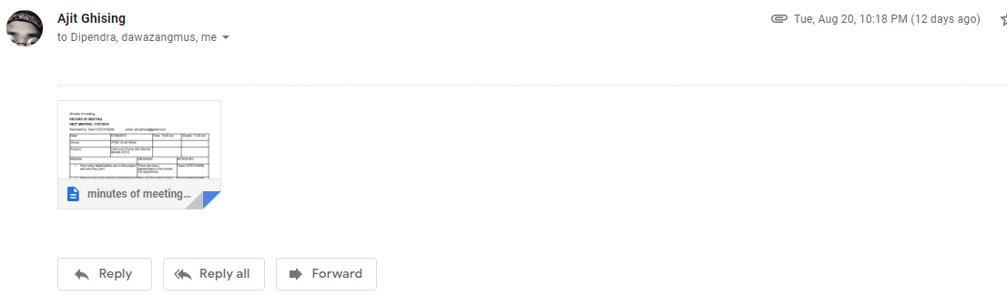

I Have a communication with the CEO of liminal VR and had a response back.

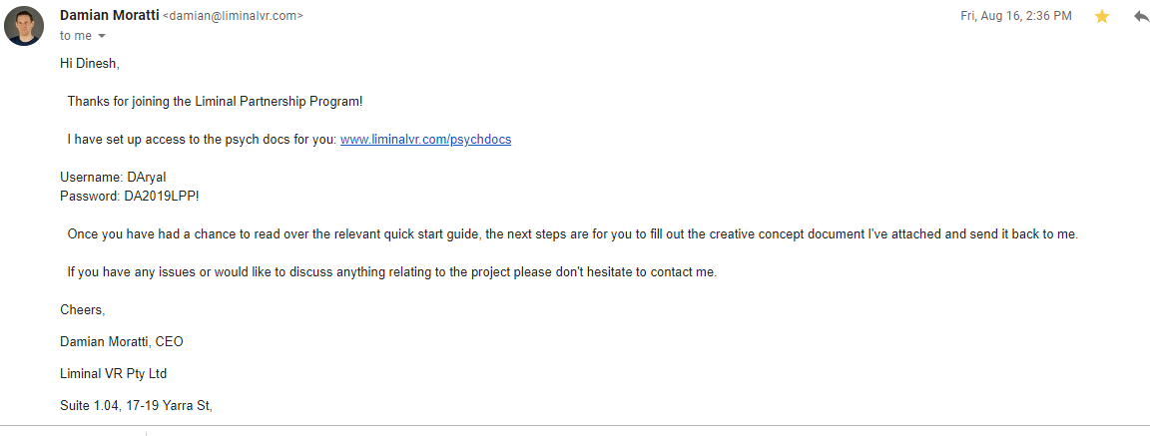

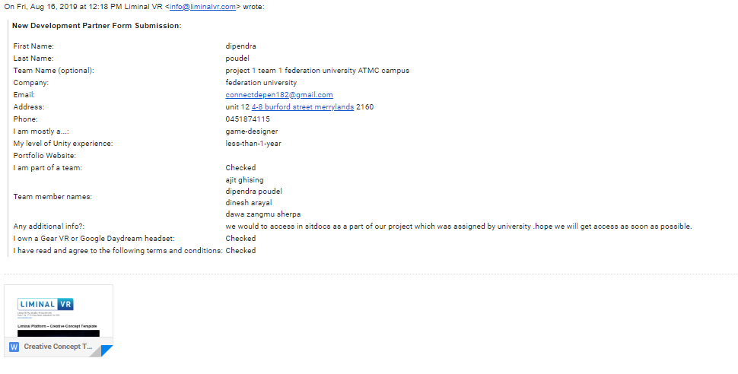

## 2.3.2 Meeting times

|  |  |  |  |  |  |  |
| --- | --- | --- | --- | --- | --- | --- |
| **Meeting Type** | **Length** | **First Meeting** | **Frequency** | **Number of Planned Meetings** | **Location/Mode** | **Objective** |
| **Team Meeting** | 12pm to 2pm | Friday  30th July  2019 | Weekly | 1 | ATMC | Group formation & Discussion |
| **Client Meeting** | 10am to 11Am | 07/08/2019 | Bi-weekly | 2 | Atmc lab | Discuss about requirement of the project |
| **Client Meeting**  **(Week 3)** | 10am to 11am | 07/08/2019 | Weekly | 4 | ATMC Druitt Street | Chat over phone by Damian |
| **Client Meeting**  **(Week 5)** | 10am to 11am | 11/08/2019 | Weekly | 6 | Atmc room 4 | Gathering of group and discussion of requirement |
| **Client Meeting**  **(Ongoing)** | 12am to 2pm | 20/08/2019 | Weekly | 13 | ATMC | Requirement and need for luminal VR |

## 2.4 Project Responsibilities

## **APPENDIX: COMMUNICATION**

## **MEETING AGENDA**

Recorded by Team1 (ITECH3208)             Email Address: dawazangmus@gmail.com

|  |  |  |  |  |  |
| --- | --- | --- | --- | --- | --- |
| Date: | 30/07/2019 | | Start time: 12pm | Finish time: 2 pm | |
| Venue: | ATMC | |  | Topic: Group formation and project discussion | |
| ISSUES: | | Discussion | | | Action by |
| 1. Group formation | | This is the first meeting that we formed our group and choose the topic and we started discussion about the project and further process for the project. | | | Dawa Zangmu Sherpa Team1) |
| 1. Discussion with lecturer | | After choosing the project we started discussing about the project with the lecturer and he explained us how to work on it.  And some more useful tips to work on the project | | | Dawa Zangmu Sherpa |

Recorded by Team1(ITECH3208)             email: connectdepen182@gmail.com

|  |  |  |  |  |  |
| --- | --- | --- | --- | --- | --- |
| Date: | 05/08/2019 | | Time: 10:00 am | | Closed: 11:00 am |
| Venue: | ATMC Druitt Street | |  | |  |
| Present: | Discussion about the requirement of the project. | |  | |  |
| Issues | | DECISION: | | ACTION BY: | |
| 1.What are the functional requirements and the qualities in terms of usability, correctness, efficiency, adaptability and speed? Address the requirements needed to be prioritize at first, if any? | | Sent the email about functional requirement to the CEO (Damian Moratti) | | Team1(ITECH3208 | |
| 2.What are the non- functional requirements and the qualities in terms of security, performance, colour scheme and branding? Address the requirements needed to be prioritize at first, if any? | | Decided to send the email about non-functional requirement to the CEO (Damian Moratti) | | Team1(ITECH3208) | |
| 3.What is the usability? how often it needs to update or modified?  What is the timeline? What are the risks? | | Decided from the group discussion between the group member, client and stakeholder modification, timeline and risk of the project. | | Team1(ITECH3208) | |
| 4. What are the main qualities required? Such as usability, correctness, efficiency, adaptability, speed What are the requirements needed for the project? | | Decided from the group discussion. | | Team1(ITECH3208) | |
| 5.What is the terminology to use? | | GitHub, blender, unity. | | Team1(ITECH3208) | |

**NEXT MEETING: 11/07/2019**

Recorded by Team1(ITECH3208)             email: azit.ghising@gmail.com

|  |  |  |  |  |  |
| --- | --- | --- | --- | --- | --- |
| Date: | 07/08/2019 | | Time: 10:00 am | | Closed: 11:00 am |
| Venue: | ATMC Druitt Street | |  | |  |
| Present: | Chat over Phone with Damian Moratti (CEO) | |  | |  |
| ISSUES: | | DECISION: | | ACTION BY: | |
| 1. How many stakeholders are in this project and who they are? | | There are many stakeholders in the liminal VR department. | | Team1(ITECH3208) | |
| 1. What are the roles of these stakeholders? | | They are the CEO and the head of each departments on specific part. | | Team1(ITECH3208) | |
| 1. What are the functional requirements and the qualities in terms of usability, correctness, efficiency, adaptability and speed? Address the requirements needed to be prioritize at first, if any? | | Gameplay and Interactivity,  Motion,  Visual design | | Team1(ITECH3208) | |
| 1. What are the non- functional requirements and the qualities in terms of security, performance, colour scheme and branding? Address the requirements needed to be prioritize at first, if any? | | Colour, Sound Effect | | Team1(ITECH3208) | |
| 1. Is there any specific methods, tools and techniques needed to be followed in this project? | | Blender and Unity | | Team1(ITECH3208) | |
| 1. Is there any specific terminology needs to be followed? | | No specific Terminology | | Team1(ITECH3208) | |

**NEXT MEETING: 20/08/2019 Meeting Holder= Dinesh Aryal**

Recorded by Team1 (ITECH3208)             Email Address: Dinesharyal000@gmail.com

|  |  |  |  |  |  |
| --- | --- | --- | --- | --- | --- |
| Date: | 11/08/2019 | | Start time: 10am | Finish time: 12:00pm | |
| Venue: | ATMC | |  | Topic: Gathering of Group and discussion of requirement over phone with Damian Moratti CEO | |
| ISSUES: | | ACTION | | | Result |
| 1. Unable of access the psych Docs | | I subscribed to luminal VR as Developer and mailed Damian Moratti to get access to psych docs (platform) | | | We got access to Psych Docs |
| 1. Unable to experience the oculus go | | I communicate with CEO of luminal VR about getting access to VR experience | | | We mailed our Co-ordinator and lecturer about the problem and decision is still pending |

**NEXT MEETING: 27/08/2019**

Recorded by Team1 (ITECH3208)             Email Address: azit.ghising@gmail.com

|  |  |  |  |  |  |
| --- | --- | --- | --- | --- | --- |
| Date: | 20/08/2019 | | Start time: 12pm | Finish time: 2 pm | |
| Venue: | ATMC | |  | Topic: Requirements need for the luminal project. | |
| ISSUES: | | Discussion | | | Action by |
| 1. No access to psych doc and creative template | | We talked to the tutor and coordinator of the ATMC and emailed about the relevant issue to all the related people respectively. | | | Ajit (Team1) |
| 2. No access to oculus Go or Samsung gear and need to experience before starting project. | | We asked to get provide the oculus Go or Samsung gear in order to experience and know how it works as we are creating the new experience targeted to the people, especially students. We are also told to email about it and so we did. | | | Ajit & Dipendra (Team1) |

**NEXT MEETING: 05/09/2019** Meeting Holder= Ajit Ghising

Recorded by Team1 (ITECH3208)             Email Address: azit.ghising@gmail.com

|  |  |  |  |  |  |
| --- | --- | --- | --- | --- | --- |
| Date: | 27/08/2019 | | Start time: 10am | Finish time: 2pm | |
| Venue: | Mirchi restaurant (Townhall) | |  | Topic: Fill up the creative template and submit it. | |
| ISSUES: | | Discussion | | | Action by |
| 1. Got approval for the Luminal VR or Samsung gear by the ATMC. | | We sent an email to the Gaurav (IT in charge) to confirm the date of arrival of the luminal VR for the project, we needed for this project. | | | Ajit (Team1) |
| 2. Unable to login to the luminal system. | | We were not able to login to the Luminal. We fill up the form and got username and password for us by Damian Moratti and get into the system. | | | Team1 |
| 3. Submitted Creative template | | We were unable to come up with an idea. We discussed more than 3 hours and came up with an idea where were agreed to create a Jurassic world experience which will lead students to have fun and provide interactive medium to learn experiencing through the VR and we believe it will help students to learn more efficiently and connect them emotionally with the animals. | | | Ajit (Team1) |